Prevent Policy & Procedure

Policy owner: | Registrar & Chief Administrative Officer
Implementation date: | November 2024
Review date: | Annually
Related policies: | Please see Section 7
Related procedures: | Please see section 7

Index
- Purpose 2
- Scope 2
- Legislative Context 2
- Policy Statement 2
- Risk Assessment and Action Plan 3
- Staff Training 3
- External Speakers 4
- Welfare and Pastoral Care 4
- Information Sharing 4
- IT Policies 4
- Students’ Union and Societies 5
- Procedure for the Referral of Concerns relating to Radicalisation 5
- Responsibilities 6
- Relationship with other Policies 6
- Review and Monitoring 7
Annex 1 – Prevent Referral Process 8
Annex 2 – Abridged Prevent Training Form 9
Version History
Version | Approved by | Revisions made | Date
4.1 | Council | Updated job titles, rearranged clauses, removal of External Speakers section to new policy.  Improvements to the Prevent Referral Procedure. | November 2024
4.2 | Registrar & Chief Administrative Officer | Inclusion of abridged training route for non-permanent staff. | May 2026

Purpose
  - The Prevent Duty Guidance for higher education institutions in England and Wales, published in March 2015, came into effect on 18th September 2015 following approval by Parliament. It sets out the expectation that universities will put in place policies for external speakers and events, the training of staff, welfare and pastoral care and the use of IT. It also makes clear that the approach to the Duty should be reasonable and proportionate in the context of the assessment of risk in the local environment.

Scope
  - This policy applies to:
    - Staff members.
    - Students.
    - Trustees and co-opted members.
    - The Students’ Union, including its societies, clubs and associations.
    - Visiting speakers and all other persons invited or otherwise lawfully on the premises.

Legislative Context
  - Section 26 (I) of The Counter-Terrorism and Security Act 2015 imposes a duty (the Prevent Duty) on universities (and other public bodies) to ‘have due regard to the need to prevent people from being drawn into terrorism’.

  - The University has taken a risk-based approach to the Prevent Duty, which is aimed primarily at safeguarding the safety and wellbeing of students and staff. The Duty is being implemented in a proportionate way that takes account of the size and context of the University and does not create additional administrative burdens on it.
  - The University’s statutory obligations under the Duty are balanced with those under the Duty to uphold the public-interest principles of academic freedom and freedom of speech.

Policy Statement
  - The University takes the need to prevent people from being drawn into terrorism seriously; accordingly, the approach to implementing the Prevent Duty has been approved by the Council of the University.
  - Following publication of HM Government’s Prevent Duty Guidance in March 2015, the University established a Prevent Working Group, whose membership comprises key members of staff and representatives of the Students’ Union. The remit of the Working Group is to advise the University on its obligations arising from the Prevent Duty and to make recommendations in respect of changes to procedures arising from it.

  - The member of senior management responsible for ensuring that the University complies with the Prevent Duty is the Registrar & Chief Administrative Officer. The Chairship of the Prevent Working Group is shared between the Registrar & Chief Administrative Officer and the Head of Academic Services. Operational responsibility for Prevent is delegated through the Head of Academic Services to the Prevent Lead who, in turn, acts as the Prevent operational point of contact for external partners and reports to the Registrar & Chief Administrative Officer on the implementation of Prevent policies and procedures by the relevant departments.

  - The University has due regard to the need to ensure students are fully consulted on the actions being taken in order to fulfil its statutory obligations. Therefore, the President of the Students’ Union is a member of the Prevent Working Group.

  - In accordance with the Prevent Duty Guidance, the University is working in partnership with the DfE Prevent Coordinators for the South East and North West, as well as other external agencies and stakeholders including Thames Valley Police and The Cheshire Police.
  - An annual report on compliance with the Prevent Duty will be submitted by the Registrar & Chief Administrative Officer to the Council via the Senate and Audit and Risk Committee (ARC).

Risk Assessment and Action Plan
  - As required by the Prevent Duty, an assessment of the risk of students being drawn into terrorism has been undertaken. The University’s Prevent Risk Register and Action Plan includes Leadership and Risk Management; Partnership; Pastoral Care and Student Welfare; External Speakers and Events; IT Policies and Use of University Computers; and SU and Sports.

  - The risk assessment and action plan shall be reviewed annually by the Senate and ARC. Any significant risk identified shall be reviewed by the Registrar & Chief Administrative Officer on the recommendation of the Prevent Working Group and included in the University’s Prevent Action Plan.

Staff Training
  - All permanent staff shall be required to undergo Prevent training and made aware of mechanisms for reporting Prevent-related concerns.

  - Staff identified as key to the operation of Prevent (“Key Staff”) shall be required to undergo refresher training at least every three years.

  - Staff currently identified as Key Staff include: the Registrar & Chief Administrative Officer, Head of Student Services, Head of Academic Services, Prevent Lead, all staff in the Student Casework Team, all staff in Legal Services, all staff in the Wellbeing, Skills and Diversity Team, all staff in the Faculty of Medicine and Health Sciences Student Support Team, all staff in Security, all staff in IT Services, and all staff in the Students’ Union. The training will also be made available to Estates and Accommodation staff on a voluntary basis.

  - Non-permanent staff such as Visiting Lecturers and volunteers, may be eligible to use an abridged Prevent training procedure and not complete the training provided by the University.

To be eligible for the abridged training route, non-permanent staff must have successfully completed initial and/or refresher Prevent training in a Higher Education, Further Education or Secondary School establishment within the last three years and have documentation to prove this.

  - They must complete the Abridged Prevent Training Form in Annex 2, attaching their proof of training to the completed form and submit this to HR.

External Speakers

  - See University of Buckingham External Speakers Policy and Procedure.

Welfare and Pastoral Care

  - Pastoral care is available to all full-time and part-time students studying on undergraduate and postgraduate programmes at the University, including those who are not based on campus. Specialist support is provided through the Wellbeing, Skills and Diversity team.

  - Any member of the University (student or staff) may identify concerns about a student being drawn potentially into violent extremism based on information received or behaviour observed.

  - The University will seek to approach such concerns from the perspective of safeguarding the individual about whom concerns have been expressed. Only where there is clear and compelling evidence of a requirement to do so will information be shared with other agencies (see Section 12: Procedure for the Referral of Concerns relating to Radicalisation below).

  - The University seeks to ensure that appropriate provision is made for those of any faith (or those without faith) to access appropriate facilities for pastoral care and for religious purposes. This provision is monitored by the Students’ Union Office.

Information Sharing
  - The University maintains links with the Channel referral and reporting process and of the opportunities for informal and formal sharing of information with relevant authorities.

  - Confidentiality will be respected with information only shared where it is considered necessary and appropriate to do so. In such instances, information will be shared in accordance with the Prevent Duty.

  - Personal Data will be shared with external law enforcement authorities in accordance with the UK General Data Protection Regulation and Data Protection Act 2018.

IT Policies
  - The University’s IT policies are reviewed with reference to the Prevent Duty regularly and make direct reference to it (see Section 12: Related Policies, Procedures and Forms below).

  - The policies set out what is and is not acceptable use of the University’s systems for research and non-research purposes. Factors considered include security-sensitive research (see Section 10.5 below) and filtering to limit access to harmful content.

  - The University operates strict controls over the management of the contents of its website to ensure that it cannot be used to promote extremist material or activities.

  - Social media platforms, including but not limited to Facebook and Twitter, are routinely monitored by the University’s content team and where any misuse of the University’s branding on social media is identified, action is taken accordingly.

Security Sensitive Research
  - The University acknowledges that some staff and students have valid reasons for researching in the areas of security, intelligence, and terrorist-related activity associated with such academic disciplines and has taken steps to ensure that they are able to do so. All research projects require ethical approval prior to commencement.

Communications
  - No communications supporting terrorism are permitted to be displayed on University premises. Any and all such material will be removed if found.

Students’ Union and Societies
  - The University and the Students’ Union work collaboratively in the provision of support for students, and this applies also to the implementation of the Prevent Duty. The President of the Students’ Union is a member of the Prevent Working Group to ensure they are consulted fully in advance of changes in policies and procedures and are in a position to disseminate information to the student body.
  - The Head of Student Services, who maintains responsibility for the Students’ Union is a member of the Prevent Working Group. This staff member provides oversight of the speakers and events being organised by the Students’ Union and for all other activities.

  - Prevent training shall also be made available to student representatives and will be promoted by the Students’ Union President and Executive.

Procedure for the Referral of Concerns relating to Radicalisation
  - Where a student or staff member has concerns that a student is, at risk of being drawn into terrorism, these concerns should be passed to the Head of Student Services or the Faculty of Medicine & Health Sciences Student Support Lead (in the case of Faculty of Medicine & Health Sciences students only) who will arrange a meeting with the student and investigate the matter, seeking to gather together the substantive information and evidence which would allow a full consideration of the case. The student will be made aware of the right to be accompanied by a support person when attending such a meeting.

  - The findings of the Head of Student Services or Faculty of Medicine and Health Sciences Student Support Lead will be communicated to the Prevent Lead. (For students studying on the professionally regulated programmes (including the MBChB and/or other Health Sciences programmes), a notification under any applicable fitness to practise or similar process may be made).
  - Users of University computers or data networks will be monitored in accordance with this Policy and Use of University Computers and Data Networks Policy. The user will receive a warning message upon an attempt to gain access to a website defined as ‘Weapons’ or ‘Questionable’ (which includes Hate and Racism) informing them that continuation to the site will result in the monitoring of the activity. An automatic email is then sent to the Prevent Lead detailing the website, the individual concerned and the date of access.

  - Where the Prevent Lead deems that either behaviour or IT usage warrants investigation under the University’s Prevent duty, available information and substantive evidence will be gathered and this will be considered by a Panel that will comprise:
    - the Registrar & Chief Administrative Officer.
    - the Head of Academic Services.
    - the Head of Student Services.
    - the Prevent Lead.
  - Following consideration, a decision will be reached as to the seriousness of the case; three potential outcomes are possible at this stage:
    - A decision that there is no further action required. In this case a confidential record of the case will be kept by the Prevent Lead.

    - A decision that there is substance to the case but at this stage only internal action is required. The exact nature of the intervention required will be determined by the Panel. Actions and a review date will be agreed. At review, the case will be reassessed and the appropriate follow up actions taken. It is anticipated that in the majority of cases the intervention will be supportive and of a safeguarding nature.
    - A decision that a referral to Channel and/or the police is required because there are serious and immediate issues of safety to the student or others, and/or there is evidence to suggest a criminal act may be committed or has been committed. This decision would be taken only in the most serious of circumstances and only when agreed by the Registrar & Chief Administrative Officer on the recommendation of the Panel. The University’s Non-Academic Misconduct Policy and Procedures may also apply. (For students studying on the professionally regulated programmes (including the MBChB and/or other Health Sciences programmes), a notification under any applicable fitness to practise or similar process may be made).

Responsibilities
  - All staff, students, visitors and contractors are responsible for following this policy.

  - The Registrar & Chief Administrative Officer has overall responsibility for ensuring the University complies with its Prevent Duty.

  - The Registrar & Chief Administrative Officer and/or Head of Academic Services are responsible for chairing the Prevent Working Group meetings.

  - The Prevent Lead is responsible for the day-to-day compliance with the Prevent Duty, to include being the central point of contact, dealing with enquiries, responding to concerns, reviewing external speaker risk assessments where required, and making external referrals when required.

Relationship with other policies and procedures

  - This Policy also takes into consideration and is in compliance with the following University polices and/or procedures:
    - Code of Practice for Freedom of Speech and Academic Freedom
    - External Speakers Policy and Procedure
    - Non-Academic Misconduct Policy and Procedure
    - Safeguarding Policy
    - Social Media Policy

Review and Monitoring
  - ARC will be responsible for monitoring the effective operation of this Policy. Academic Services will be responsible for reviewing and updating the Policy in accordance with statutory requirements and making recommendations for the approval of same to both the Senate and ARC.

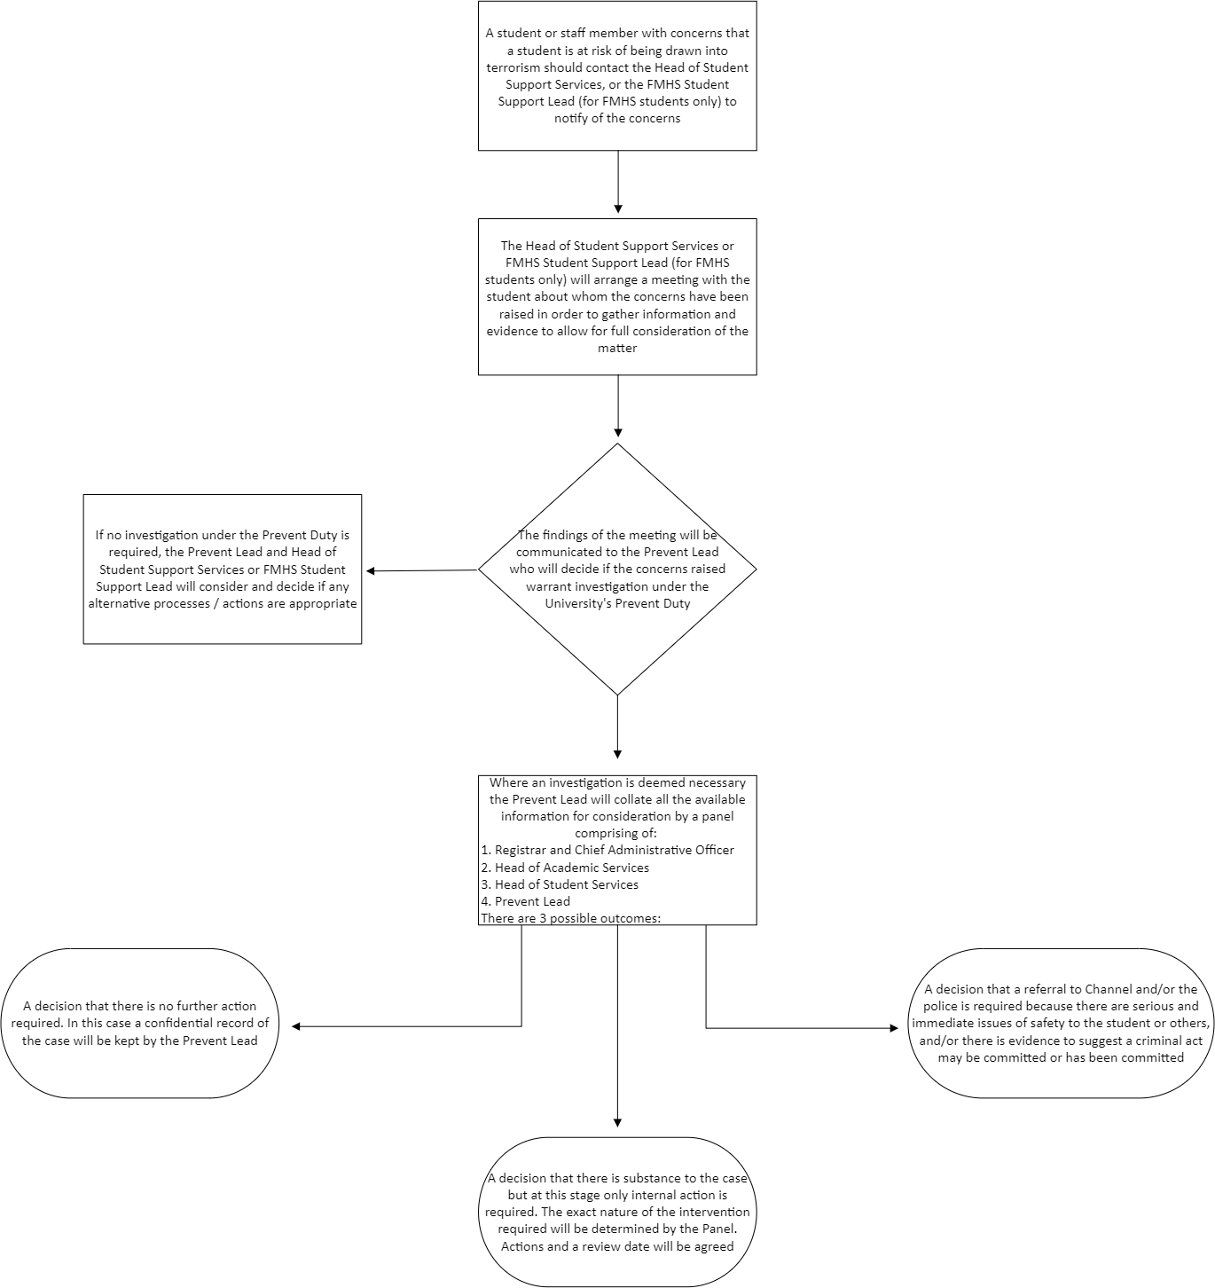

Annex 1: Prevent Referral Process

Annex 2: Abridged Prevent Training Form

Name:

School / Department:

Name of organisation where you completed your Prevent training:

Date of training:

Proof of training attached (screenshot/pdf etc) Yes No
If no proof of training can be provided, you will be required to take the training provided by the University.

I confirm that I have read and agree to abide by these documents:
The University of Buckingham Prevent Policy & Procedure
I am also aware of who are the relevant personnel with respect to Prevent
and how to report a Prevent related concern

Signed: Date:

